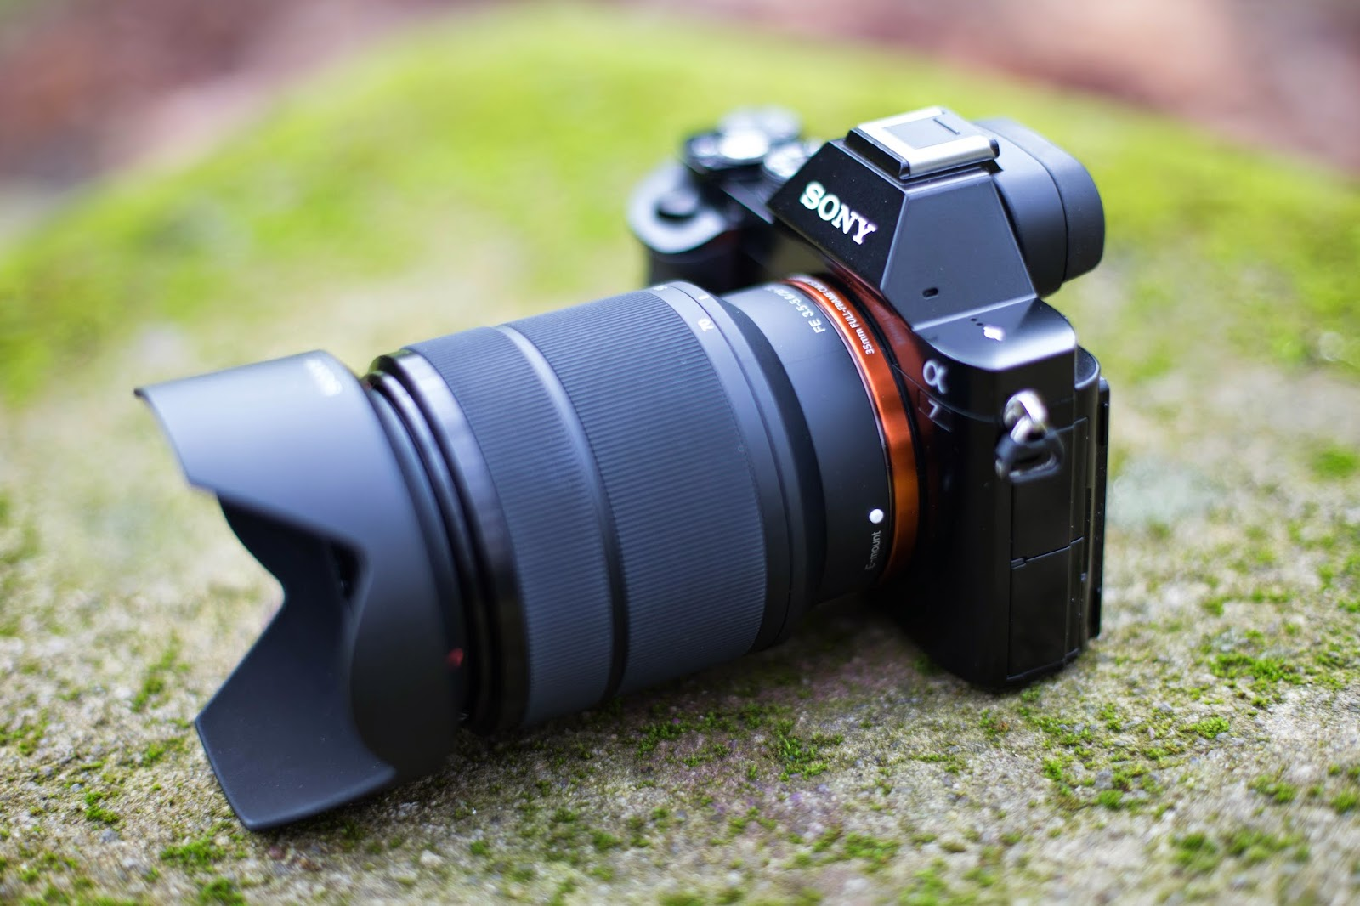

SONY ALPHA 7 III (ILCE-7M3)

Professional Full-Frame Mirrorless Camera

Introduction
The Sony Alpha 7 III (A7 III) is one of Sony's most popular full-frame mirrorless cameras, designed for professional photographers, videographers, and content creators. It offers exceptional image quality, outstanding autofocus performance, excellent low-light capability, and professional 4K video recording. Because of its reliability and performance, it is widely used in wedding photography, portrait photography, wildlife photography, travel photography, sports photography, filmmaking, and commercial work.
The Sony A7 III combines advanced technology with a lightweight, weather-sealed body, making it an excellent choice for professionals and serious enthusiasts.

Key Specifications
Feature | Details
Camera Type | Full-Frame Mirrorless Camera
Sensor | 24.2 MP Exmor R CMOS Sensor
Image Processor | BIONZ X Processor
Lens Mount | Sony E-Mount
ISO Range | 100–51,200 (Expandable to 204,800)
Continuous Shooting | Up to 10 FPS
Autofocus Points | 693 Phase Detection + 425 Contrast Detection
Video Recording | 4K UHD at 30fps
LCD Screen | 3.0-inch Tilting Touch Screen
Viewfinder | 2.36M-dot OLED Electronic Viewfinder
Battery | NP-FZ100 Rechargeable Battery
Memory Card Slots | Dual SD Card Slots
Weight | Approximately 650 g

Main Features

1. Full-Frame Sensor
The 24.2-megapixel full-frame sensor captures highly detailed images with excellent dynamic range and natural colors. It performs exceptionally well in both bright daylight and low-light environments.

2. Fast Autofocus
The A7 III features 693 phase-detection autofocus points, allowing it to lock onto subjects quickly and accurately. Real-Time Eye AF ensures sharp focus on people and animals.

3. Professional Video Recording
The camera records 4K UHD videos with excellent detail, making it suitable for YouTube creators, filmmakers, wedding videographers, and commercial production.

4. High-Speed Shooting
Continuous shooting at 10 frames per second enables photographers to capture fast-moving subjects such as sports, wildlife, and action events.

5. 5-Axis Image Stabilization
Built-in image stabilization minimizes camera shake, resulting in sharper photos and smoother handheld videos.

6. Excellent Battery Life
The NP-FZ100 battery delivers approximately 700+ shots per charge, making it one of the best mirrorless cameras for long shooting sessions.

7. Dual Memory Card Slots
Two SD card slots provide backup storage, ensuring greater safety for important photos and videos.

8. Weather-Sealed Body
The durable magnesium-alloy body is resistant to dust and moisture, making it suitable for outdoor photography.

Advantages
- 24.2 MP Full-Frame Sensor
- Outstanding image quality
- Excellent low-light performance
- Fast and accurate autofocus
- 4K video recording
- 10 FPS continuous shooting
- 5-axis image stabilization
- Dual SD card slots
- Long battery life
- Compact and lightweight design
- Professional build quality

Applications
The Sony Alpha 7 III is ideal for:
- Wedding Photography
- Portrait Photography
- Wildlife Photography
- Sports Photography
- Landscape Photography
- Street Photography
- Travel Photography
- Fashion Photography
- Commercial Photography
- YouTube Content Creation
- Documentary Filmmaking
- Professional Video Production

